Create big sphere for air volume

Create and locate cylinders in volume

Partition big sphere with the cylinders

A new part is created with the cylinders as partitions

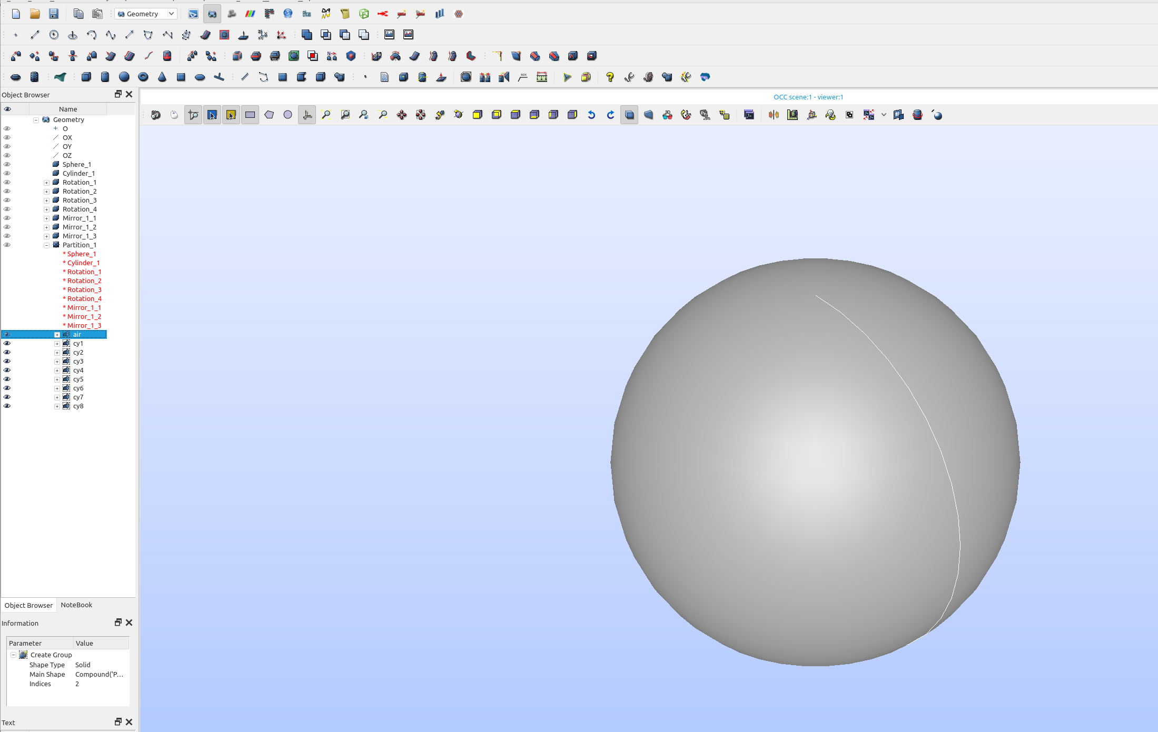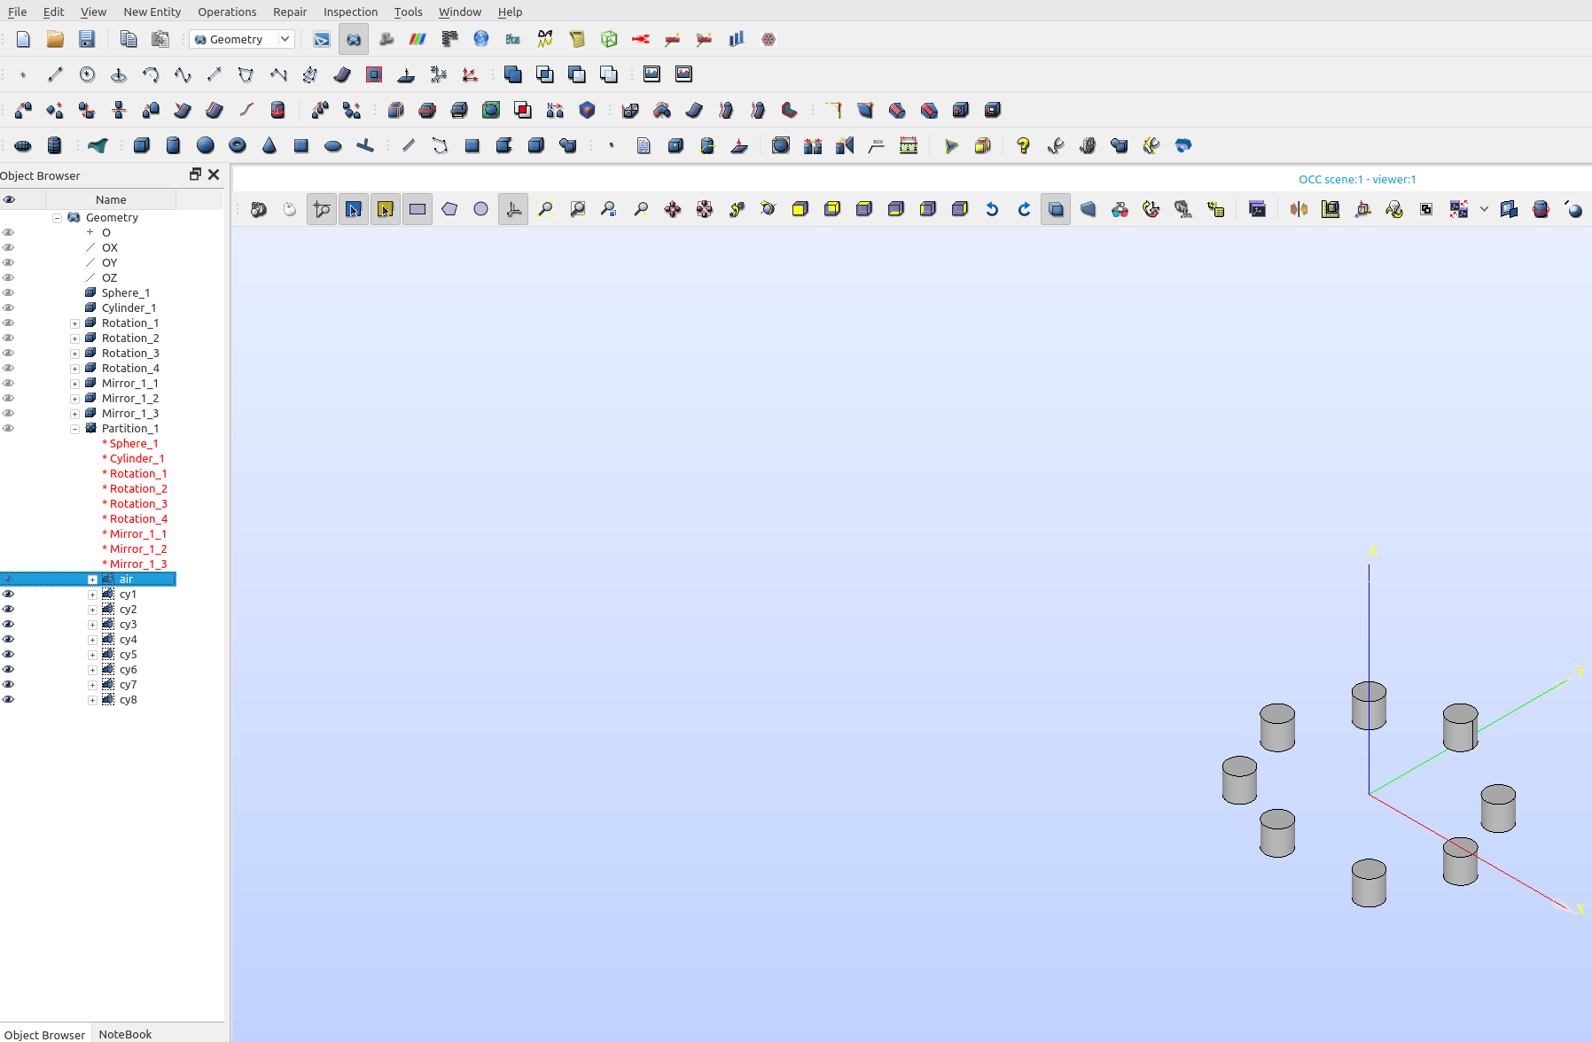

In the partition part, in geometry groups of volumes are created for the bodies, and the boundaries are done by grouping faces.

To group the inner cylinders you have to hide the outer sphere, to see them.

The one part with the groups is meshed and the geometry groups automatically become mesh groups.

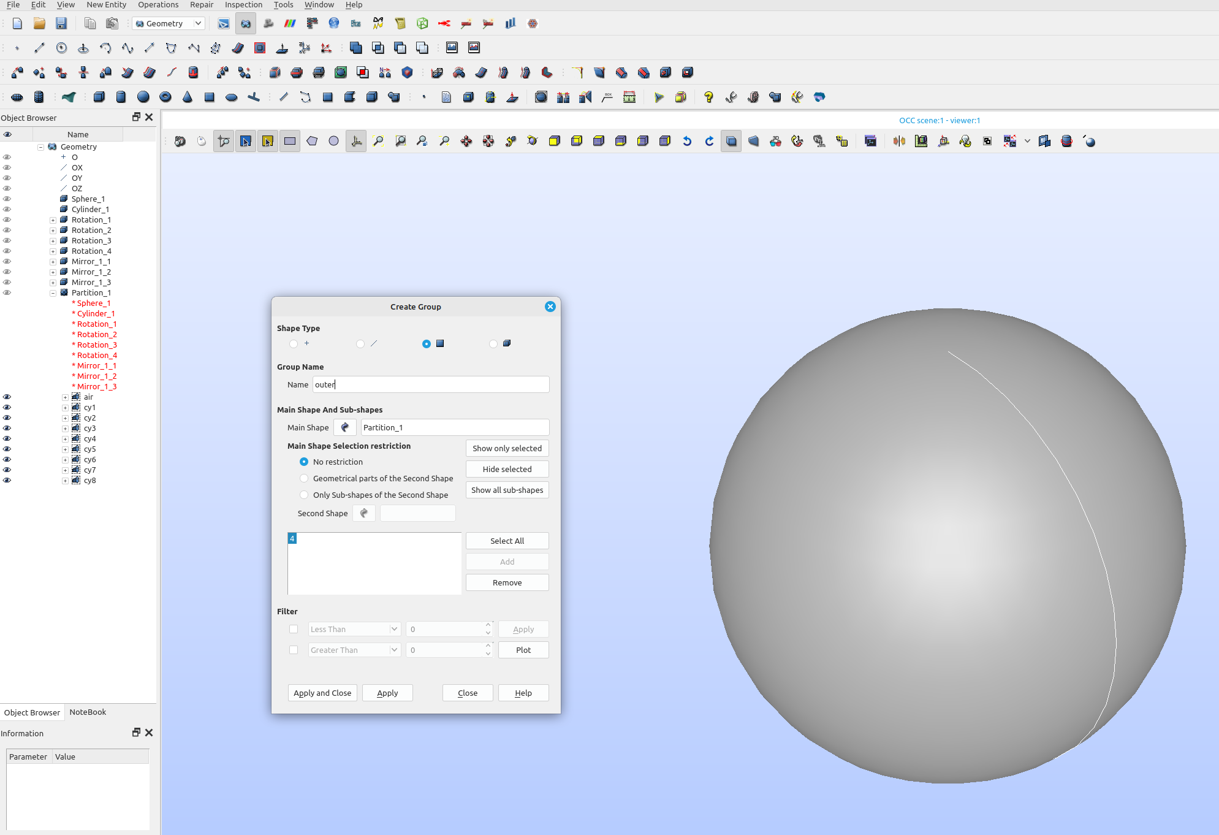

The universal file is opened in ElmerGUI and the volume groups are bodies, and the outer surface group becomes a boundary. ElmerGUI puts all ungrouped faces in the last boundary.

I do not need boundary elements between the cylinders and the air volume since they share nodes. I would only need a boundary if I needed to apply a boundary condition, or sum up output on the boundary.

